**SYDNEY HARBOUR BRIDGE**

* **Height:** 134 m (440 ft)
* **Length:** 1.149 m (3.770 ft)
* **Width:** 48.8 m (160 ft)
* **City:** Sydney, New South Wales
* **Country:** Australia
* **Built:** July 28th, 1923 – January 19th, 1932

The Sydney Harbour Bridge is a heritage-listed steel through arch bridge in Sydney, spanning Sydney Harbour from the central business district (CBD) to the North Shore. The view of the bridge, the harbour, and the nearby Sydney Opera House is widely regarded as an iconic image of Sydney, and of Australia itself. Nicknamed "The Coathanger" because of its arch-based design, the bridge carries rail, vehicular, bicycle and pedestrian traffic.

Under the direction of John Bradfield of the New South Wales Department of Public Works, the bridge was designed and built by British firm Dorman Long of Middlesbrough (who based the design on their 1928 Tyne Bridge in Newcastle upon Tyne) and opened in 1932. The bridge's general design, which Bradfield tasked the NSW Department of Public Works with producing, was a rough copy of the Hell Gate Bridge in New York City. This general design document, however, did not form any part of the request for tender, which remained sufficiently broad as to allow cantilever (Bradfield's original preference)

and even suspension bridge proposals. The design chosen from the tender responses was original work created by Dorman Long, who leveraged some of the design from their own Tyne Bridge which, though superficially similar, does not share the graceful flares at the ends of each arch which make the harbour bridge so distinctive. It is the eighth longest spanning-arch bridge in the world and the tallest steel arch bridge, measuring 134 m (440 ft) from top to water level. It was also the world's widest long-span bridge, at 48.8 m (160 ft) wide, until construction of the new Port Mann Bridge in Vancouver was completed in 2012.

The Sydney Harbour Bridge went on to be added to the Australian National Heritage List on 19 March 2007 and to the New South Wales State Heritage Register on 25 June 1999.

**HISTORY**

*Sketches of designs submitted when tenders were called for a harbour crossing in 1900*

There had been plans to build a bridge as early as 1815, when convict and noted architect Francis Greenway reputedly proposed to Governor Lachlan Macquarie that a bridge be built from the northern to the southern shore of the harbour. In 1825, Greenway wrote a letter to the then "The Australian" newspaper stating that such a bridge would "give an idea of strength and magnificence that would reflect credit and glory on the colony and the Mother Country".

Nothing came of Greenway's suggestions, but the idea remained alive, and many further suggestions were made during the nineteenth century. In 1840, naval architect Robert Brindley proposed that a floating bridge be built. Engineer Peter Henderson produced one of the earliest known drawings of a bridge across the harbour around 1857. A suggestion for a truss bridge was made in 1879, and in 1880 a high-level bridge estimated at £850,000 was proposed.

*Norman Selfe's winning design at the second competition c.1903*

In 1900, the Lyne government committed to building a new Central railway station and organised a worldwide competition for the design and construction of a harbour bridge. Local engineer Norman Selfe submitted a design for a suspension bridge and won the second prize of £500. In 1902, when the outcome of the first competition became mired in controversy, Selfe won a second competition outright, with a design for a steel cantilever bridge. The selection board were unanimous, commenting that, "The structural lines are correct and in true proportion, and... the outline is graceful".[33] However due to an economic downturn and a change of government at the 1904 NSW State election construction never began.

A unique three-span bridge was proposed in 1922 by Ernest Stowe with connections at Balls Head, Millers Point, and Balmain with a memorial tower and hub on Goat Island.

**Planning**

In 1914 John Bradfield was appointed "Chief Engineer of Sydney Harbour Bridge and Metropolitan Railway Construction", and his work on the project over many years earned him the legacy as the "father" of the bridge. Bradfield's preference at the time was for a cantilever bridge without piers, and in 1916 the NSW Legislative Assembly passed a bill for such a construction; however, it did not proceed as the Legislative Council rejected the legislation on the basis that the money would be better spent on the war effort.

Following World War I, plans to build the bridge again built momentum. Bradfield persevered with the project, fleshing out the details of the specifications and financing for his cantilever bridge proposal, and in 1921 he travelled overseas to investigate tenders. His Confidential Secretary Kathleen M. Butler handled all the international correspondence during his absence, her title belying her role as a technical adviser. On return from his travels Bradfield decided that an arch design would also be suitable, and he and officers of the NSW Department of Public Works prepared a general design for a single-arch bridge based upon New York City's Hell Gate Bridge. In 1922 the government passed the Sydney Harbour Bridge Act No. 28, specifying the construction of a high-level cantilever or arch bridge across the harbour between Dawes Point and Milsons Point, along with construction of necessary approaches and electric railway lines, and worldwide tenders were invited for the project.

*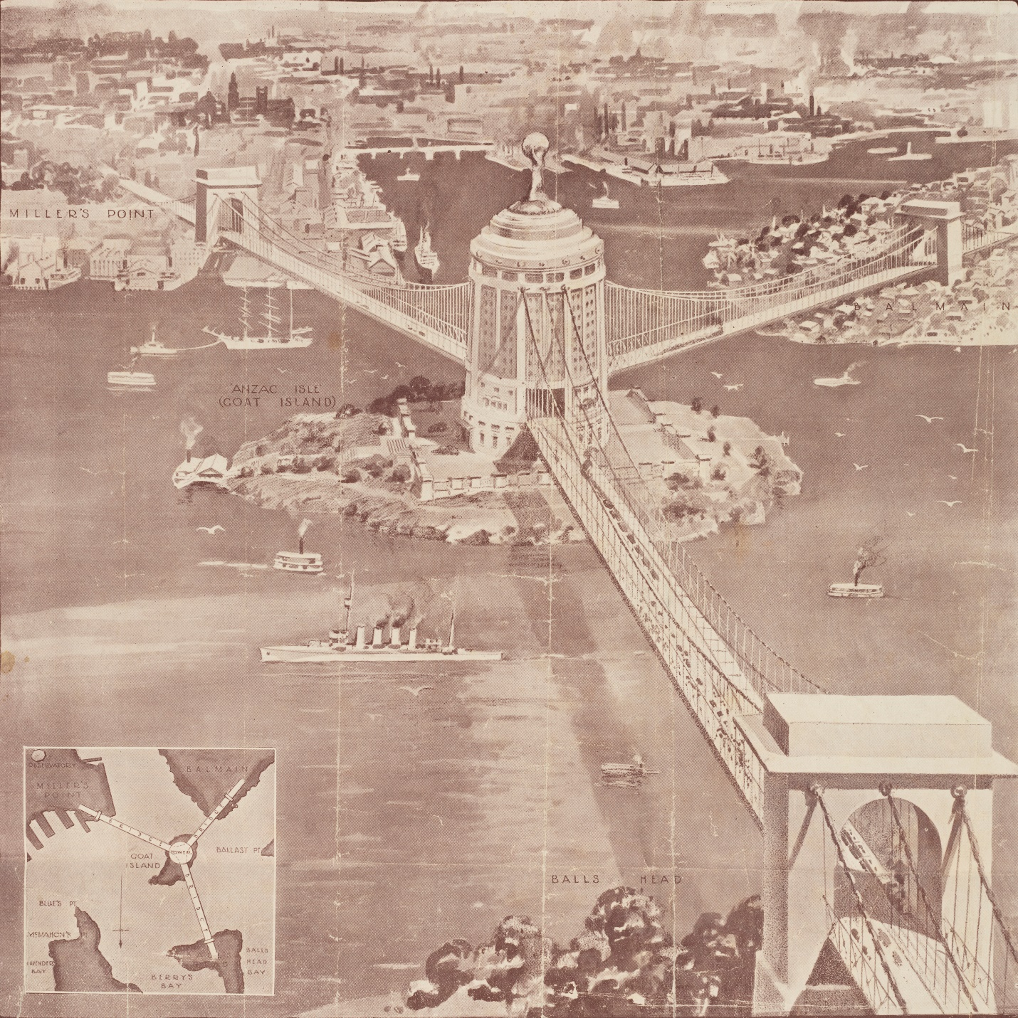Norman Selfe's winning design at the second competition c.1903*

As a result of the tendering process, the government received twenty proposals from six companies; on 24 March 1924 the contract was awarded to British firm Dorman Long and Co Ltd, of Middlesbrough well known as the contractors who later built the similar Tyne Bridge of Newcastle Upon Tyne, for an arch bridge at a quoted price of AU£4,217,721 11s 10d. The arch design was cheaper than alternative cantilever and suspension bridge proposals, and also provided greater rigidity making it better suited for the heavy loads expected. In 1924, Kathleen Butler travelled to London to set up the project office within those of Dorman, Long & Co., "attending the most difficult and technical questions and technical questions in regard to the contract, and dealing with a mass of correspondence".

Bradfield and his staff were ultimately to oversee the bridge design and building process as it was executed by Dorman Long and Co, whose Consulting Engineer, Sir Ralph Freeman of Sir Douglas Fox and Partners, and his associate Mr. G.C. Imbault, carried out the detailed design and erection process of the bridge. Architects for the contractors were from the British firm John Burnet & Partners of Glasgow, Scotland. Lawrence Ennis, of Dorman Long, served as Director of Construction and primary onsite supervisor throughout the entire build, alongside Edward Judge, Dorman Long's Chief Technical Engineer, who functioned as Consulting and Designing Engineer.

The building of the bridge coincided with the construction of a system of underground railways in Sydney's CBD, known today as the City Circle, and the bridge was designed with this in mind. The bridge was designed to carry six lanes of road traffic, flanked on each side by two railway tracks and a footpath. Both sets of rail tracks were linked into the underground Wynyard railway station on the south (city) side of the bridge by symmetrical ramps and tunnels. The eastern-side railway tracks were intended for use by a planned rail link to the Northern Beaches; in the interim they were used to carry trams from the North Shore into a terminal within Wynyard station, and when tram services were discontinued in 1958, they were converted into extra traffic lanes. The Bradfield Highway, which is the main roadway section of the bridge and its approaches, is named in honour of Bradfield's contribution to the bridge.